NeighborMedia  A program of CCTV    Christian Herold’s Blog |  | 

Part I. Speaker’s Corner: Residents Decry Supreme Court Decision on Affirmative Action

Part II. How Diverse are Massachusetts and Cambridge Colleges?

Speaker’s Corner. The May 15 Interviews (2012)
Speaker’s Corner is an occasional series of interviews with passersby in Cambridge on issues of interest.
I hope you'll enjoy meeting in this 8-minute video your fellow Cantabrigians and passersby, who in response to the day’s question were troubled, outraged, noncommittal, sensible, prudent, lucid, poetic, and compassionate. And introducing the resourceful David Barsir, an intern with Cambridge Community TV, who came to film the interviews, but gamely volunteered to conduct them after watching folks pass me by.
For this Speaker's Corner, I oversimplified the Supreme Court's decision in the question: “The Supreme Court bans affirmative action at U. Michigan. Your thoughts?” While the truncated question was useful for piquing protest and reflection, it was unfair to my interviewer and interviewees, who in any case were more cautious than I was. I apologize. For penance, I offer a more in-depth look at the issues in two additional posts--Part II compares race in higher education in Michigan to that in Cambridge and Massachusetts; Part III closely synopsizes the Supreme Court case, Schuette vs. Coalition to Defend Affirmative Action, et al.
The Supreme Court of the United States (SCOTUS) did not ban affirmative action on April 22. Rather, it rather struck down a lower court's challenge to the legal standing of Michigan (or any state) to prohibit affirmative action and diversity policies--in public education, hiring, and contracts. States may continue to permit affirmative action, the Court held, but they may also ban it. Michigan voters enacted the ban through a 2006 state-wide referendum amending their constitution such that the state “shall not discriminate against, or grant preferential treatment to, any individual or group on the basis of race, sex, color, ethnicity, or national origin in the operation of public employment, public education, or public contracting.” The heroic language echoes that of the Fourteenth Amendment’s Equal Protection Clause, but its intention and effect, contrariwise, was to undo affirmative action and diversity.
Multiple states besides Michigan, moreover, have passed similar referendums. With the decision in this case, SCOTUS upheld existing affirmative action bans not just in Michigan, but in Oklahoma (2012), New Hampshire (2011), Arizona (2010), Nebraska (2008, higher education only), Washington (1998), Florida (1999), Texas (1997 reversed in 2005), and California (1995). Source.
The vote in the decision of Schuette was 6 to 2. Justice Sonia Sotomayor wrote the dissent, joined by Justice Ruth Bader Ginsburg. Justice Elena Kagan recused herself, as she has for many SCOTUS cases, because she worked on related issues as Solicitor General. Cantabrigian Justice Stephen Breyer, though considered a liberal justice, voted with the conservative majority on narrow grounds of precedents, which I discuss in Part III.

What’s at Stake?
While the states’ bans extend to all public hiring and contracting, the Court only focused on affirmative action and diversity policies in higher education admissions.
Sotomayor noted that SCOTUS had already extensively limited affirmative action in higher education from the 1978 Bakke decision to two 2003 cases involving the University of Michigan and its law school. She summarizes the limitations:
"[A]dmissions policy must use race flexibly and must not maintain a quota," she wrote. "And even this limited sensitivity to race must be limited in time and must be employed only after serious, good faith consideration of workable race-neutral alternatives" (Sotomayor 17).
Such policies may not be used primarily to improve the lot of minorities, but “only in a very limited way in an effort to create a diverse student body” (Sotomayor 3, continuation of note 1). In deference to these SCOTUS precedents, she said, she preferred to use the expression “race-conscious,” rather than “affirmative action.”
The explicit language of the ban, however, forbids even the use of “race-conscious” policies or diversity as an educational mission.
Though she granted it had no bearing on the main arguments in the case, Sotomayor sought to keep in view the historic social consequences of the ruling—the lost opportunity for education and young minorities.
"Diversity ensures that the next generation moves beyond the stereotypes, the assumptions, and the superficial perceptions that students coming from less-heterogeneous communities may harbor, consciously or not, about people who do not look like them….And it acknowledges that 'to cultivate a set of leaders with legitimacy in the eyes of the citizenry, it is necessary that the path to leadership be visibly open to talented and qualified individuals of every race and ethnicity'" (Sotomayor 56; and quoting from prior SCOTUS case, Grutter).
As Sotomayor documents, black enrollment at the University of Michigan prior to affirmative action was less than 1% (1966). Beginning with affirmative action, which began in the early 1970s, the percentage of underrepresented minorities in the freshman class rose to a peak of 7% in 2006, while the total population of college-age blacks (whether attending college or not) at that time was 16%. After the referendum changed the state constitution, the percentage of blacks at Michigan dropped to 5%, a 30% decline, even as the black percentage of the population of increased to 19% (Sotomayor 47).
Here are two charts illustrating Sotomayor’s statistics. The first chart shows the percentage of students at the University of Michigan before, with, and after affirmative action compared to the percentage of college-age blacks in the state.
Chart no longer available. (One chart, see Part II, is preserved.)
The second chart shows the gap between enrollment and state population. (Data is from Sotomayor, except Michigan’s black population in 1966 is from U.S. Census Bureau data.)
Chart no longer available.
There have been similar declines in minority enrollment at the other colleges that banned affirmative action. Sotomayor refers us to a New York Times article accompanied by charts that examine these decreases. The article finds Hispanic students less disadvantaged, but black student enrollment diving.
Thank you for your help with the video and Part I: David Barsir, Andrew Held, Saul Tannenbaum, Charlton McIlwain, Nat Herold.

Sources
The case: Schuette, Attorney General of Michigan v. Coalition to Defend Affirmative Action, Integration and Immigration Rights and Fight for Equality By Any Means Necessary (BAMN), et al. Note that the case is paginated with each justice's contribution beginning on a page 1.

Related articles by Chris Herold
“Speaker’s Corner: Larry Summers—Fed Chair?”
“Did Gingrich Snooker Harvard?” –An article featuring pointed discussion of the SCOTUS Citizen’s United case.
Longer version of the videotaped interviews (12 minutes)

Further Reading, Part I
The Michigan Civil Rights Initiative
What We Have Lost Because of Michigan's Affirmative Action Ban (Detroit Free Press):
See Part II, next page

Part II. How Do Our Colleges Stack Up Against Michigan’s?
In the previous post, we gave the floor to U.S. Supreme Court Justice Sonia Sotomayor to address the social consequences of ending affirmative action in Michigan and elsewhere. How far can we boast that we do it better in Massachusetts—or Cambridge? How do the Massachusetts state schools, which continue to embrace race-conscious admissions, stack up against Michigan’s state schools? How well do our four private colleges do—Harvard, MIT, Lesley University, and Cambridge College?
The original ideal in higher education of affirmative action, if not of diversity, was to approach parity between the percentages of minorities in schools and those in the general population. This particularly makes sense for public colleges and schools whose presumed mission includes serving their respective populations. Hence, along with columns illustrating percentages of races at different colleges, we include columns showing the composition of the general college-age populations (i.e. both students and non-students) where the colleges are located.

Three Quick Wonky Notes
1. We make three kinds of comparison:
• Racial/ethnic percentages between colleges;
• These percentages between colleges and the general college-age populations where the colleges are located (i.e. parity);
• Parity between colleges.
2. For the U.S., state, and Cambridge data about college-age residents, we use numbers from the U.S. Census Bureau, mostly its estimates for 2013. For the college data, we use colleges’ self-reported “common data sets” (CDS), mostly from 2012-2013 (Harvard’s is 2011-2012). We include more detail on sources at the bottom of the post.
3. It’s not immediately clear what value the City of Cambridge data has. We can’t really use it to make town-gown comparisons, because the number of private college students residing in Cambridge and the number of college-age Cambridge residents is virtually the same, so we suppose they are the same people!
Here’s a master chart for reference (more detailed charts guide discussions).
Race at Mich, Mass, & Private Colleges.png. Chart not available – One is extant below “Cambridge’s Four Colleges”

Massachusetts & Michigan Public Colleges: Parity Comparisons
Key findings:
• Massachusetts state colleges, though still substantially under-parity, do a much better job at enrolling black students than Michigan’s colleges. Blacks are severely underserved in Michigan.
• While Michigan does better than Massachusetts at enrolling Hispanics, both states have extremely poor Hispanic representation relative to their populations.
Mass & Michigan Parity2.png, Chart not available
In this chart, 100% means that the percentage of undergraduates of a particular race is the same as that of the general college-age population. For example, there is the same percentage of whites at Michigan colleges as in Michigan’s general college-age population. Numbers above 100% mean the percentage is higher; below 100%, it is lower. The Michigan numbers include all of its 15 undergraduate colleges; the Massachusetts numbers include all four undergraduate UMass colleges.
The chart reveals the severity of the disconnect between blacks at Michigan state colleges vs. the state college-age black population. There are proportionately half as many blacks at the schools as in the population. At the University of Michigan (Ann Arbor), which Sotomayor discusses, the parity is below 25% (or 4% of the students at that college).The UMass colleges do better, but are still about 13% under-parity. One reason Massachusetts schools may do better is that Michigan has a higher black poverty (39%) rate than Massachusetts (29%), creating more disadvantageous conditions for black education (2011-2012 poverty statistics). Failure of Michigan's educational mission, we can assume, in turn exacerbates black poverty.
Hispanics do slightly better in Michigan than in Massachusetts, but are still grossly under-parity in both states, only 70% in Michigan and 66% in Massachusetts. Hispanics are the most-underserved population in Massachusetts public education.
Whites in Michigan, on the other hand, comprise virtually the same proportion of students as are in the general population. Interestingly, in Massachusetts, the parity of whites (87%) and blacks (89%) are close to each other, with blacks slightly higher.
Asians are the only group above parity in both state college systems—116% of the general college-age population in Michigan and 107% in Massachusetts.

Cambridge's Four Private Colleges
Cambridge has four private colleges—Harvard, MIT, Lesley, and Cambridge College. Here are their statistics compared with each other and with the City of Cambridge. Private colleges, of course, have never had to directly follow affirmative action regulations. (Presumably any federal funding of grants and contracts would require following diversity guidelines.) There is also the question of what can be usefully compared. Clearly, private colleges can be compared with one another, but is it also useful to compare them with the populations of the locations in which they are sited? Public colleges and schools must serve their respective states, cities, and districts, but private colleges generally need not. Yet we can still ask the question of how the private colleges serve the public interest in these ways, even if the answers must be interpreted with care.
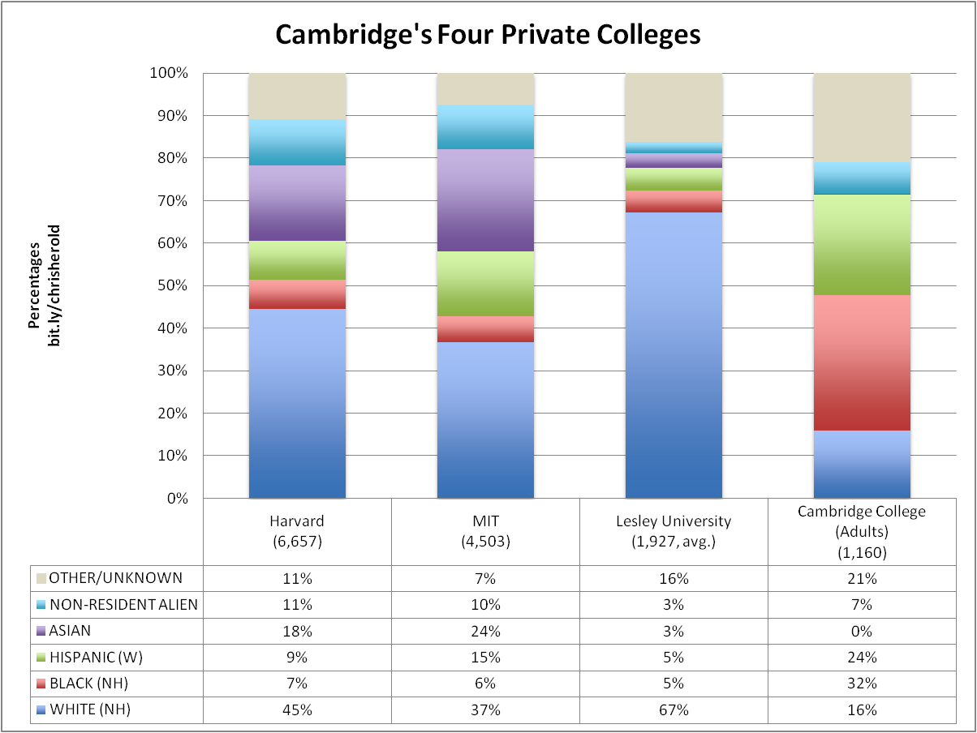
Lesley College has the lowest percentage of blacks (5%) of the four colleges. (Boston University has an even more dismal percentage of blacks—3%). Lesley also has a relatively high proportion, if small actual numbers, of the categories of American Indian/Alaskan Native (13 students, or .7%, vs. .9% in the college-age U.S. population) and Hawaiian/Pacific Islander (4 students, or .2%, the same proportions as in the college-age U.S. population) relative to their student population and in comparison with Harvard & especially MIT.
Cambridge College provides exemplary service to blacks (32% of students) and Hispanics (24% of students). To some extent, comparing Cambridge College’s numbers to those of the other colleges and the city population is comparing apples to oranges, as its mission is to serve older adults. (Only 51 of the colleges’ 1,160 undergraduates reside in Cambridge, according to the Town Gown Report.

Harvard & MIT
Key Findings:
• Harvard & MIT have 370% and 500% respectively more Asians than the U.S. college-age population.
• Hispanics are exceptionally well represented at MIT—136% of the Hispanic college-age population in Massachusetts, though only 80% of that of the U.S.
• Blacks remain substantially under-parity at Harvard and MIT vis-à-vis the U.S. population—under 50% parity for each.
Race at Harvard & MIT.png. Chart not available
As we see in the above chart, compared to the U.S. (15%), and even Massachusetts (9%), blacks have low numbers at Harvard (7%) and MIT (6%).
Here are the parity numbers (Harvard is 44% of the U.S. black college-age population; MIT has 40%):
Black Parity at Harvard2.png, Chart not available
The Harvard percentages are surprising, because reports are that Harvard accepted blacks at the rate of 11.8% 2011 (from Grio article cited below) and 11.9% in 2014 (Journal of Blacks in Higher Education [JBHE]).
We see two possible reasons for this. First is that the number of blacks who actually matriculated at Harvard is substantially below the 12% accepted. The JBHE article above says that Harvard has a black “yield rate” (those who actually attend) of 70%, in which case the actual enrolled blacks would comprise 8.3% of the college body. This leaves us with a gap of 1.3%.
A second, very interesting reason would be if the press office releases and the common data sets differ in who is counted as black. For example, it’s possible that the press office’s reports of 12% admissions may include immigrants and non-resident aliens of color, whilst the common data sets might not. The percentage of non-resident aliens listed on the CDS at Harvard is 11%. If, as a thought-experiment, 4% from this stack were considered by the press office to be “black,” e.g. from Africa or the Caribbean, that would bring us to the 7% rate reported in the CDS. If you take the yield rate factor into account, you only need to transfer 1.3% from the non-resident alien stack to the black stack to make it equal 7%. Relatedly, this intriguing Grio article reports that in 2007, 40% of the black category in Ivy League admissions were African immigrants (vs. African-American “descendants of slaves”). During the Speaker’s Corner’s interviews, David Barsir interviewed two young Africans (neither of whom appear on the edited video). We requested clarification from Harvard about all of these factors and will post any reply.
Harvard and MIT have considerably higher Asian populations than either the state or U.S. percentages. At MIT, Asians make up nearly 25% of the student population. Asians comprise 18% of undergraduates at Harvard, and only 5% in the U.S. and 8% in Massachusetts. American whites (i.e. resident non-alien whites) are, interestingly, under-parity at Harvard and MIT, especially MIT, where whites are 35% under-parity.
We pass no judgment on Asian over-parity or white under-parity; our ethical position focuses on service to historically discriminated-against populations that continue to suffer from the standpoints of identity politics and economics.
Both private colleges have much higher Hispanic percentages than the public colleges, still under-representing the U.S. Hispanic population by 21%, which presumably is concentrated in the U.S. Southwest, but massively higher than those in the Massachusetts college-age population.
We presume, based on the way the CDS categories are structured, that the Harvard and MIT Hispanics are U.S. residents, rather than, say non-resident aliens from Latin America. We would want ideally to confirm how the CDS data is structured. Is it possible for a student to check both Hispanic and non-resident alien on their admissions form, and if so, how does the CDS register that?
Both Harvard and MIT report large non-resident populations, which is not surprising, as the colleges have international reputations. The U.S. Census Bureau data does not include non-resident alien data, so we can’t directly compare that factor.

Concluding Questions to Our Readers
We make a few observations about these comparisons, but as we are new to writing about statistics, we would appreciate your help in thinking through causes and ramifications. There is also the question of values. We believe in affirmative action and the ideal of parity for public education and applaud that ideal for private colleges, yet ask how far private colleges should be held accountable to the parity standard. Opposed to the parity ideal of affirmative action is the vaguer guideline of diversity, which Harvard is credited with contributing to the Supreme Court’s vocabulary (in 1978). Is that an effective standard, given that their black parity is only 44% vis-à-vis that of the U.S.?
***Please see forthcoming: Part III The Supreme Court Case: Discussion***

SPECIAL THANKS for Part II of this three-part series to:
• Clifford Cook, Cambridge Community Development Department
• Saul Tannenbaum, NeighborMedia
• William Wojtkowski, U.S. Census Bureau
• Charlton McIlwain, NYU Dept. of Media, Culture & Communication, and Director, Project on Race in Political Communication
• Andrew Held

More on the Data
•U.S. Census Bureau (USCB) is the source for numbers of college-age residents (both students and non-students) in the U.S., Massachusetts, Michigan, and the City of Cambridge. Most of them are from the Bureau’s estimate for 2013. The City of Cambridge is directly from the 2010 census (PCT12 tables). The census is supposed to include all residents including students both in off-campus housing and dorms. The USCB data does not include the category “non-resident alien” as the school data does. Again, much thanks to Clifford Cook and to William Wojtkowski.
• Common Data Sets (CDS) are provided by each college and all have the same categories. Our charts follow their categories, except that we put their American Indian/Alaskan Native and Hawaiian/Pacific Islander and 2+races numbers together because there are so few, and then we collapse this with their “unknown” category—presumably those college applicants who did not indicate race on their admissions materials—to create an “Other/Unknown” category. By far most of the “Other/Unknown” category are the unknowns. I also only include white Hispanics as that is the largest Hispanic category. Most CDS are for the school year 2012-2013. Harvard’s latest data, inexplicably, is from 2011-2012. Cambridge College provides their 2011-2012 set and their 2013-2014 set, so I averaged the two. (The best way to find these is via a Boolean Google search: “CDS”, [college name], [academic year].)
• 2013 Town Gown report from The City of Cambridge provides numbers of undergraduate students residing in Cambridge by private college. Again, thanks to Clifford Cook.
• As mentioned above, the value of including of the City of Cambridge stack is unclear. The numbers of all the town’s college-age students and the number of students listed as residing in Cambridge by the town’s four private college are virtually the same! That means that the Cambridge column provides no useful contrast of town vs. gown The implication, moreover, is that virtually every young adult in Cambridge is attending college in Cambridge and that if they are not, they have left town, to live, work, or attend college elsewhere. Compare that with Michigan, where only half of the college-age adults attend one of the state schools.

